Exp.No: 3Determination and plotting of Force of attraction between woelectric Charges and two parallel conductors separated by varying distance.
Date:
Aim:
To Determination and plotting of Force of attraction between wo electric Charge sand two parallel conductors separated by varying distance between them using SCILAB.
Softwarerequired:
- SCILAB version6.0.1
Program:

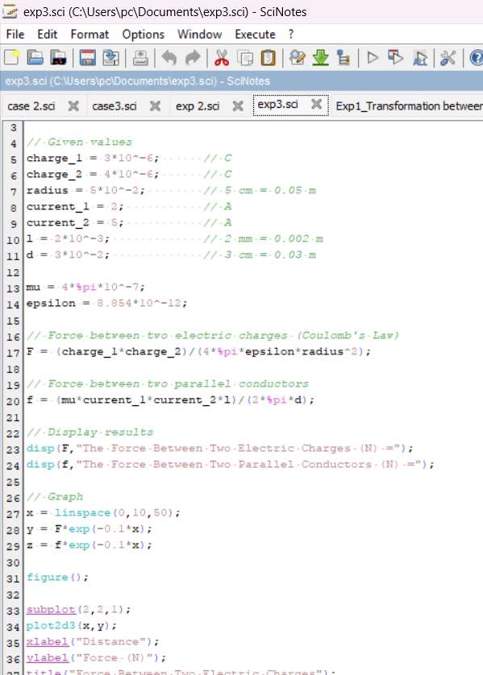

OUTPUT

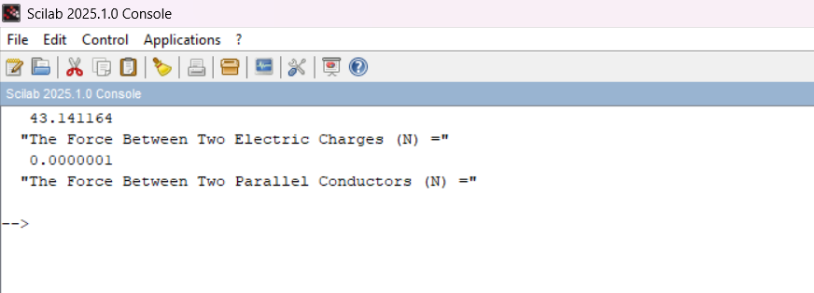

Calculation:

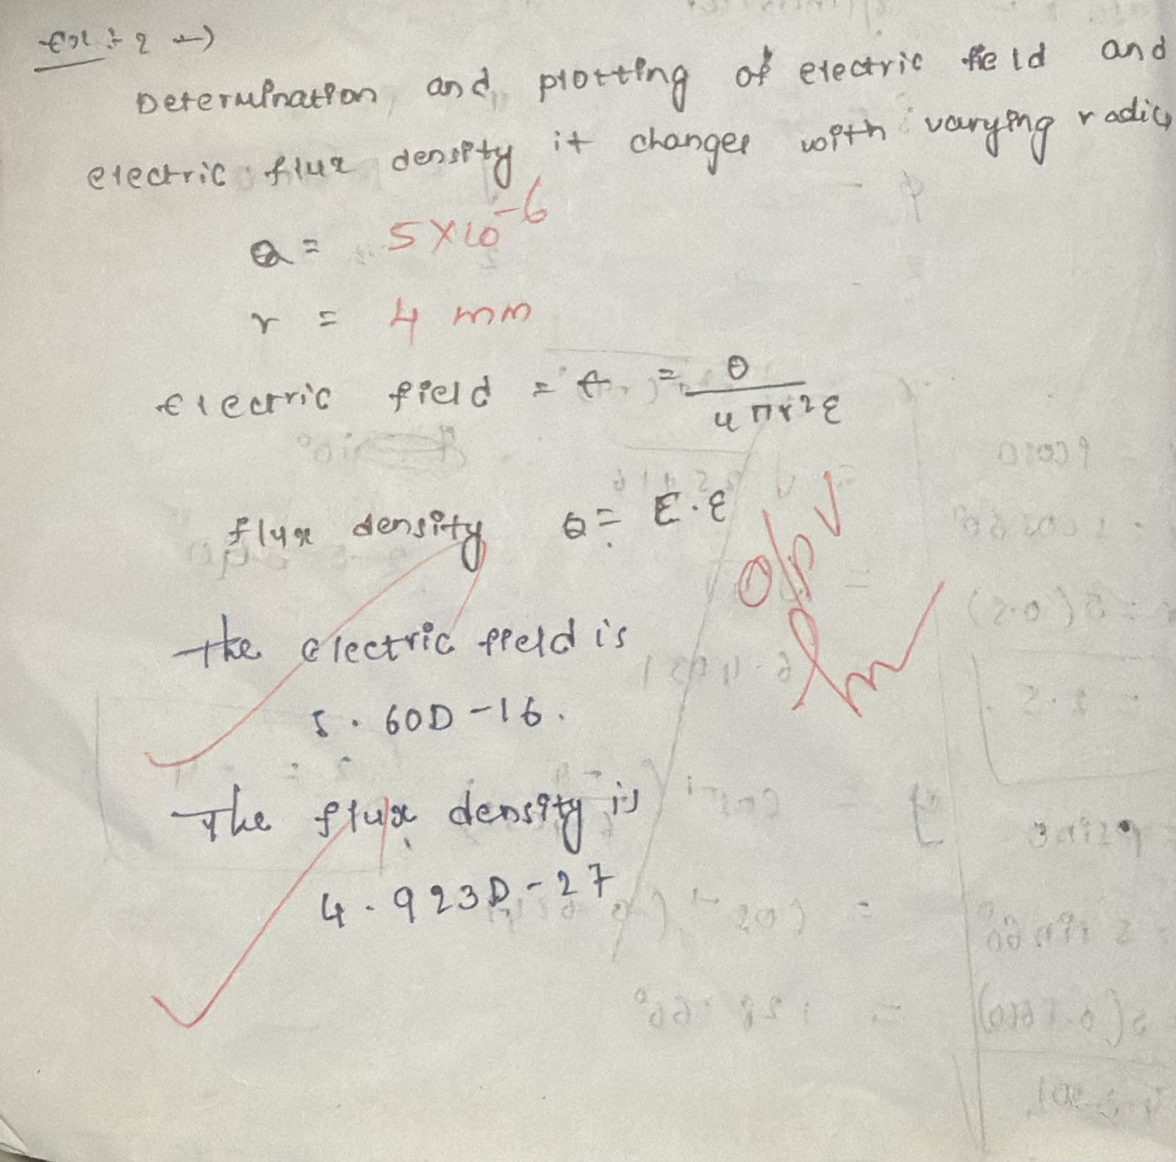

Result:
Thus the program was verified for the force of attraction orrepul sionacting along a straight line between two electric charges is directly proportional to the product of the charge sandinversely to the square of the distance between them using SCILAB was successfully.

Result:
Thustheprogramwasverifiedfortheforceofattractionorrepulsionactingalonga straightlinebetweentwoelectricchargesisdirectlyproportionaltotheproductof thechargesandinverselytothesquareofthedistancebetweenthemusingSCILAB wassuccessfully.

